3iQ Bitcoin ETF(BTCQ)

- (“3iQ”) is a Canadian investment fund manager focused on providing investors with exposure to digital assets, disruptive technologies and the blockchain space.
- Founded April 9, 2020
- CEO Fred Pye
- Value CAD 346.88M
Airboss of America Corp.(BOS)
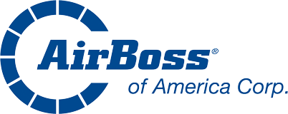
- AirBoss of America Corp is a Canada-based manufacturer of rubber-based products for the resource, military, automotive and industrial markets. It operates in three segments: Rubber Solutions, Engineered Products, and AirBoss Defense Group.
- Founded 1989
- CEO Gren Schoch
- Value CAD 104.70 million
B2Gold Corp.(BTO)
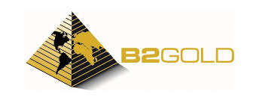
- B2Gold Corp is an international, low-cost, senior gold mining company. It has three operating open-pit gold mines in Mali, Namibia, and the Philippines and numerous exploration projects across four continents.
- Founded 2007
- CEO Clive Johnson
- Value CAD 4.39 billion
Badger Infrastructure Solutions Ltd.(BDGI)

- Badger Infrastructure Solutions Ltd is North America's provider of non-destructive excavating services. Its key technology is the Badger Hydrovac, which is used primarily for safe excavation around critical infrastructure and in congested underground conditions.
- Founded 1992
- CEO Robert G. Blackadar
- Value CAD 1.41 billion
Ballard Power Systems Inc.(BLDP)
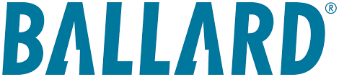
- Ballard is a world leader in proton exchange membrane fuel cell, power system development, and commercialization. The company's principal business is the design, development, manufacture, sale and service of PEM fuel cell products for a variety of applications, focusing on power product markets of heavy-duty motive (consisting of bus, truck, rail, and marine applications), material handling, and stationary power generation. Sales are concentrated in the U.S., Europe, and China.
- Founded 1979
- CEO Randy MacEwen
- Value CAD 412.19 million

Bank of Montreal(BMO)

- Bank of Montreal is a diversified financial-services provider based in North America, operating four business segments: Canadian personal and commercial banking, U.S. P&C banking, wealth management, and capital markets.
- Founded 1817
- CEO Darryl White
- Value CAD 73.34 billion
Bank of Nova Scotia(BNS)
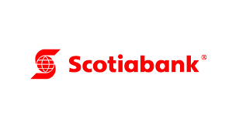
- Bank of Nova Scotia is a global financial services provider. The bank has five business segments: Canadian banking, international banking, global wealth management, global banking and markets, and other. It offers a range of advice, products, and services, including personal and commercial banking, wealth management and private banking, corporate and investment banking, and capital markets.
- Founded 1832
- CEO Scott Thomson
- Value CAD 64.16 billion

Barrick Gold Corporation(ABX)
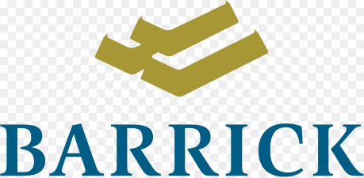
- Barrick Gold Corp is one of the world's largest gold producers, operating mines in North America, South America, Australia, and Africa. The company consist of nine gold mines namely Carlin, Cortez, Turquoise Ridge, Pueblo Viejo, Loulo-Gounkoto, Kibali, Veladero, North Mara, and Bulyanhulu.
- Founded 1983
- CEO Mark Bristow
- Value CAD 28.06 billion
Bausch + Lomb Corporation(BLCO)
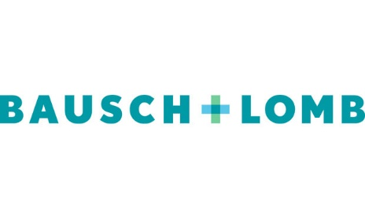
- Bausch & Lomb, headquartered in Laval, Quebec, Canada, is the fourth-largest vision care company by sales in the United States and the market leader in consumer vision care in India and China. The firm, which was previously a subsidiary under parent company Bausch Health, was spun off to become a public company once again in May 2022.
- Founded 1853
- CEO Brent Saunders
- Value CAD 6.13 billion

Bausch Health Companies Inc.(BHC)

- Bausch Health Companies Inc. is a global company that develops manufactures and markets a range of pharmaceutical medical device and over-the-counter products primarily in the therapeutic areas of eye health gastroenterology and dermatology.
- Founded 1959
- CEO Thomas J. Appio
- Value CAD 4.07 billion
Baylin Technologies Inc.(BYL)
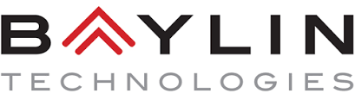
- Baylin Technologies Inc. is a diversified global wireless technology company. The Company focuses on the research, design, development, manufacture and sale of passive and active radiofrequency (RF) products, satellite communications products, and supporting services. Its products are marketed and sold under the brand names Galtronics, Advantech Wireless, Alga Microwave and Mitec VSAT.
- Founded 1978
- CEO Leighton Carroll
- Value CAD 51.45 million

